**Question 1:**

**Write the program for deleting an element from the beginning and from any position.**

**Ans:**

#include <stdio.h>

int main()  
{  
 int array[100], position, c, n;

printf("Enter number of elements in array**\n**");  
 scanf("%d", &n);

printf("Enter %d elements**\n**", n);

for (c = 0; c < n; c++)  
 scanf("%d", &array[c]);

printf("Enter the location where you wish to delete element**\n**");  
 scanf("%d", &position);

if (position >= n+1)  
 printf("Deletion not possible.**\n**");  
 else  
 {  
 for (c = position - 1; c < n - 1; c++)  
 array[c] = array[c+1];

printf("Resultant array:**\n**");

for (c = 0; c < n - 1; c++)  
 printf("%d**\n**", array[c]);  
 }

return 0;  
}

**Output:**

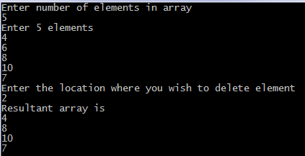

**Question 2:**

**Write the program for printing the array after rotating it k times towards left, where k would be taken as user input.**

#include <stdio.h>

void leftRotatebyOne(int arr[], int n);

void leftRotate(int arr[], int d, int n)

{

int i;

for (i = 0; i < d; i++)

leftRotatebyOne(arr, n);

}

void leftRotatebyOne(int arr[], int n)

{

int temp = arr[0], i;

for (i = 0; i < n - 1; i++)

arr[i] = arr[i + 1];

arr[i] = temp;

}

void printArray(int arr[], int n)

{

int i;

for (i = 0; i < n; i++)

printf("%d ", arr[i]);

}

int main()

{

int arr[] = { 1, 2, 3, 4, 5, 6, 7 };

leftRotate(arr, 2, 7);

printArray(arr, 7);

return 0;

}

